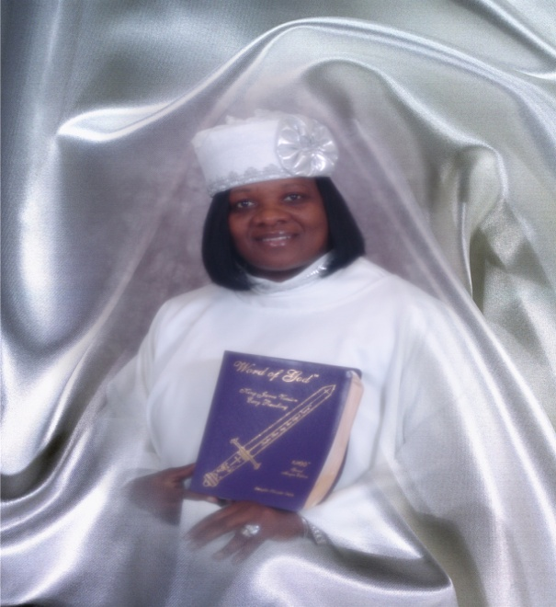
Greater Faith Calvary’s Nursing Guild Ministry.

Established September 13, 2015

Pastor: District Elder Willie Clemons
Director: Evangelist Margelet Clemons
President: Sister Evelyn Murry
Vice President: Sister Dianna Matlock
Secretary: Sister Keisha Luckett

This Ministry is made up of volunteer members of the Greater Faith Calvary Pentecostal Church to aid the pastor and care for the people in church and in the spirit.
- We are not a Medical Nursing Ministry.
- We do not dispense medications or medical treatment in any capacity under any circumstances.
- We are only to assist until the arrival of medical professional.

Duties of the Ministry Includes:
- Comfort and support to the visitors and members during regular worship, funerals, revivals, and other programs as needed.
- To assist the alter for prayer and alter calls.
- To aid and support the pulpit.

Goals and Objectives:
- To use God given gifts to help those in need.
- To be dedicated and faithful to the church nursing Ministry.
- To be a Holy Ghost filled ministry with fasting and prayer.
- To be first aid trained and certified.
- To be educated on the health needs of the congregation.
- To assist in developing health education and promote programs (etc.) health fairs…

